





Intermediate Accounting 2 Project:
EARNINGS MANAGEMENT

Submitted By:
Nawaf Masoudi NAB046
Ali Redah Al-Sihati SC0009
Mosleh Al – Shaker NBB117

ABSTRACT
The last decade has characterized as a period of a financial crisis. Several high-profile cases have highlighted the role of financial reporting and problems related to Earnings Management. The avalanche of these so-called "accounting scandals" and the alarming increase in accounting reviews and reformulations have drawn the attention of accounting researchers and the popular press worldwide. Questions that need explanation include:
1) "What is Earnings Management or mismanagement?"
2) "What is the role of judgment in ethical financial reporting?"
3) "What are the difficulties in identifying Earnings Management?
This article reviews the literature on the subject and then identifies and places on a revenue management continuum some of the leading causes worldwide for the past decade

INTRODUCTION
The objective of financial reporting is defined as "providing financial information, about the reporting entity that is useful to exist and potential investors, lenders and other creditors in making decisions about providing resources to the entity" in the Conceptual of the International Accounting Standards Board (IASB) Framework for financial reporting (IASB, 2010). To create useful information that can help users of financial statements make better decisions. Accounting judgments and estimates require critical thinking. The Pathways Commission on Higher Education in Accounting, created jointly by the American Institute of Certified Public Accountants (AICPA) and the American Accounting Association (AAA), created the vision model diagram shown on the right side of Figure 1 to show the reality of "What is accounting?" to students in their first course in accounting. "Accounting reality" (vision model) shows professional accountants who make complex accounting judgments that affect and are affected by economic activity and contribute to a prosperous society. However, the "perception of public accounting" illustrated on the left of Figure 1 shows that professional accountants focus on recording financial transactions and preparing financial statements using black and white accounting rules.
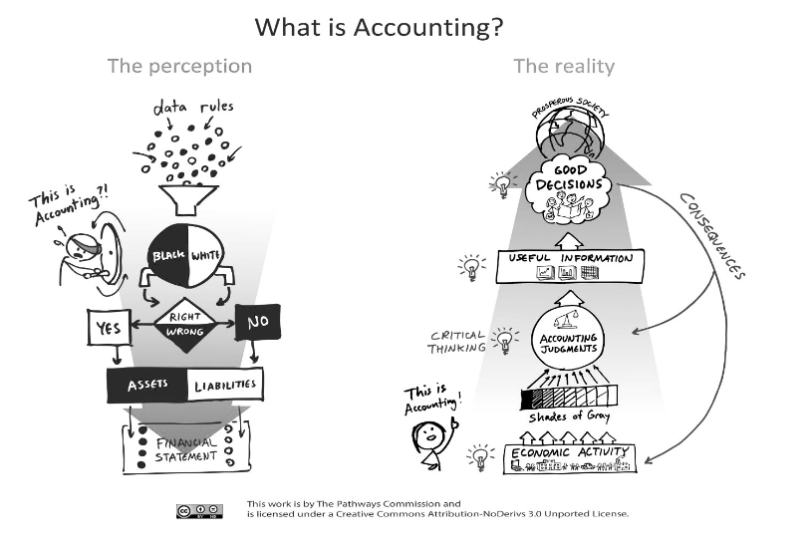

Figure 1: The Pathways Commission's Vision Model
Source: The Vision Model at www.PathwaysCommission.org
Since the application of financial reporting standards requires considerable judgment, it also creates opportunities for Earnings Management. While auditing the financial statements provides confidence that such decisions are reasonable, there are many cases where the audit firms were unable to detect misstatements or fraud. It is because it is difficult to determine if there is a tolerable amount of Earnings Management (Barth, 2018). The document reminder presents, in order, a definition of earnings management, discussion of the interrelationships between judgment, estimates, and earnings management, the difficulty of identifying earnings management, examples of selected earnings management cases, and a conclusion.

EARNINGS MANAGEMENT
"Earnings Management" generally focuses on artificially increasing (or decreasing) the income, earnings, or earnings per share figures through aggressive accounting tactics.
Consider these example definitions of Earnings Management
• Intentional intervention in the process of external financial information to obtain some private profit.
• Use of judgment in financial reporting and transaction structuring to alter financial reporting to mislead some stakeholders about the underlying economic performance of the business or to influence contractual results that depend on informed accounting judgments.
• These definitions illustrate that earnings management is a complex process involving the accounting judgment that underlies the income statement and the other related financial statements and disclosures.
.As can be seen in Figure 2 (McKee, 2005), each element in the financial statements is the result of the complex interaction of these two decisions by the administration: a judgment of commercial structuring -An arrangement of financial information financial statements They are first affected by business structuring decisions that involve the business in economic activities. These decisions
result in transactions or changes in value that must be recorded according to generally accepted accounting principles (GAAP). Why GAAP offers both financial alternatives

Figure 2: Business Structuring Decisions versus Financial Reporting Decisions

Management’s Stucturing Decision

Generally Accepted Accounting Principles

Recorded in Accounting System
Transaction or Value Change
Economic Activities

Reporting treatments and based on judgment, various accounting decisions must be made to record transactions in the accounting system from which the financial statements and related disclosures are prepared. Example of how:
• Temporary transactions to result in a favorable moment of recognition of income or expenses
•. Write contracts, such as for leases and pension agreements, GAAP requires managers to make numerous financial reporting judgments that have an impact on reported earnings.
Examples of these financial reporting judgments that could subtly shade earnings in one direction or another include:
• Long-term construction contracts require estimates of progress towards completion and costs to be completed. Managers Could Use Optimistic Estimates Of Progress Towards Completion To Boost Profits.
• Depreciation calculations require estimates of useful life and protection values. Managers can assess life optimism, use the hedging value of depreciation assets, and reduce depreciation costs.
• Accounts receivable must be declared at their net realizable value. Managers could use optimistic collection estimates to exaggerate earnings
• Costs should be classified as product costs or period costs. By organizing some limit costs as a product rather than period costs, managers can reduce expenses during inventory growth.
• Gains on the disposal of assets can be fully recognized in the sale period. Managers could time the sale of appreciated assets such as marketable securities and fixed assets to increase profits
• Software development companies must estimate the point at which software products' technological viability is reached and capitalize on the costs of software development after that point. Managers could speed up this date to avoid the immediate expense of some software development costs.
• The anticipated costs of complying with the guarantee obligations must be accumulated and adjusted to income. By making optimistic estimates of product warranty costs, managers could reduce current expenses.
• Ordinary repairs are charged to expenses as incurred, while major renovations are capitalized. By treating ordinary repairs as significant repairs, managers could increase current earnings.
• Inventories must declare at the lowest cost or market. Managers may use optimistic market values, resulting in reduced inventory write-downs (Jackson y Pitman, 2001
Most often, these examples representing accounting accruals (estimates) —adjustments to operating cash flows in the calculation of net income— are the means of achieving a rational allocation of costs to expenses. Still, they could also be used to produce a figure desired profit. Some argue that Earnings Management within reasonable limits can be beneficial to a company and add value (Yaping, 2006). By their nature, accumulations involve estimates, require subjective judgment, and are difficult to verify objectively by auditors before completion. While auditors are likely to analyze financial statement accounts that include managers' subjective judgments, nonetheless, they are unlikely to completely counter deliberate and pervasive efforts to shadow accumulations in one direction or another. Auditors develop a range of fair values for an account but rarely insist on an accurate estimate within that range. However, auditors, financial executives, and regulators must understand the motivations for Earnings Management to counter it effectively.
In a study of 347 cases of fraudulent financial reporting in the past decade, the Committee of Sponsoring Organizations (COSO) identified numerous motivations for falsifying financial reporting (Beasley et al., 2010, p. 14), including:
• Meet the expectations of the external profits of analysts and others.
• Achieve internal financial goals or improve the appearance of the business
• Conceal the deterioration of the company's financial situation
• Increase the share price
• Strengthen the financial position for the financing of capital or outstanding debt
• Increase the compensation of the administration by achieving bonus objectives and a greater appreciation of the shares
• Cover misappropriated assets for personal benefit
Overly aggressive Earnings Management is a form of fraud and differs from reporting an error. Management, wanting to show earnings at a certain level or following a particular pattern, looks for loopholes in financial reporting standards that allow them to adjust the numbers as much as possible to achieve their desired objective or to meet financial analysts' projections. These adjustments amount to fraudulent financial reporting when they fall "outside the bounds of acceptable accounting practice." The COSO special report also identified the most common financial fraud techniques among the 347 fraud companies to include (Beasley et al., 2010, p. 17): *
• Incorrect revenue recognition (recording fictitious revenues or recording revenues prematurely) 61%
• Overvaluation of assets (excluding debtors)51%
• Underestimation of expenses/responsibilities 14%
• consider negotiating also cited 24%
• Disguised use of transactions with related parties 18% •
• Other miscellaneous techniques (acquisition, joint ventures, etc.) 20%
* Totals greater than 100% due to multiple cases of abuse

Earnings Management is considered a pressing problem in current accounting practice. It is relatively easy for an auditor to spot errors, but Earnings Management can involve sophisticated fraud that is disguised. The requirement that management affirms that accounts have been properly prepared does not offer protection when those managers have already entered into conscious fraud and deception. Auditors must distinguish fraud from error by identifying the presence of intention. Part of the difficulty lies in the accepted recognition that there is no "correct" earnings figure and that the line between acceptable and unacceptable financial information may be difficult to determine, as illustrated in the next section.

Judgment, Estimates and Earnings Management
The accounting, structural, and critical elections must be carried out within the framework of GAAP. Most people understand that GAAP is the set of rules, practices, and conventions that describe what acceptable financial reporting to external stakeholders is. Still, they may find it surprising that a single, regular, and daily accounting choice is ethical. Or unethical. The difference between a moral and wrong accounting choice is often simply the degree to which the decision is made. The problem with many accounting judgments is that there is no explicit limit beyond which an election is unethical. Therefore, a perfect routine accounting decision, such as estimating expenses, may be illegal if the estimated amount is extreme, but entirely ethical if it is reasonable. GAAP does not tell managers what is specifically standard and what is extreme. It's more like a speed limit sign that just says, "Don't drive too fast!"
Wrong debt estimation is an excellent example of an accounting decision that many managers must make. Since a company extends credit as an incentive for customers to buy, the estimated losses of those who do not pay are considered a cost of the current period. However, it will not be known until future periods, which customers will not pay and what is the amount of non-payment will be. GAAP requires that a wrong debt estimate be recorded as an expense in the same fiscal year in which the product income is recorded. This follows a basic accounting concept of accumulating equivalent costs with related income.
Even small changes in estimates can have significant effects on reported earnings. To illustrate, suppose a company has an operating income of $ 200,000 before the bad debt estimate. Also, suppose that management estimates bad accounts to be $ 12,000, or 2% of net sales of $ 600,000. The income statement would look like this:
Revenue $200,000
Less: Estimated uncollectible accounts expense 12,000 Net
$ 1,88,000
However, the fact that bad accounts will be $ 12,000 is not always so clear. Suppose that the average costs of bad debts at the same level of sales have ranged from $ 10,000 to $ 14,000 (1.33% to 3.67% of net sales) with no apparent specific pattern over the past five years. A financial manager who would like to report the highest possible income in the current period would be justified in using the amount of $ 10,000 for the estimate of expenses for the current year, even though $ 10,000 is the bottom of the historical range. That same manager could use $ 14,000 to be conservative in a year when the economy is weak.
The same manager might even be justified in using $ 6,000 if there was evidence that customer credit research and the improved economy would be improved during the current fiscal year to reduce future bad debt losses. But what if that manager were to use an estimate of $ 1,000 simply because that number would meet the desired net income target for the fiscal year? Or at the other end of the spectrum, management could choose the highly conservative estimate of $ 11,000 because the company any reason (perhaps to avoid taxes or to appear unattractive to an acquisition) did not want to show higher income. Since the $ 1,000 or $ 11,000 is not reasonably supported, its use would cross the ethical line into possible financial fraud. However, GAAP does not draw a clear path for the ethical use of judgment or unethical purpose.
As viewed in Figure 3 taken from Dechow and Skinner (2000), the thinking of a reporting income continuum may additionally vary from questionable conservative too conservative to impartial to aggressive to fraudulent. The query turns into the place to draw the lines. Should they be extensive latitude as in Figure 3a or greater slim as in Figure 3b? The reply does make a difference. In this one instance of an instead modest distinction in estimate from $1,000 to $11,000 (.33% to 3.67% of internet sales), it makes a distinction of $.10 per share ($.99–-$.89) or about 10% of revenue per share (EPS). Given that EPS is the most regularly quoted overall performance measure for agencies and that when groups omit analysts' revenue estimates through $.01, seventy-five percent of the time, it is through greater than the estimate. Finally, reflect on the consideration that the estimate of uncollectible money owed is solely one of the dozens of estimates made through administration in getting ready the economic statements.
Figure 3 also gives a clear picture of how there is no "bright line" in GAAP to notify the managers of what can and cannot be acceptable. When this illustration depicts the magnified effect of just one judgment, it also makes the earlier stand, that management represented without various structural and estimate decisions that can affect reported earnings. Management is to make a choice that approximately reflects the company's performance. It is not always easy to conclude that what is appropriate for a company should be suitable for another company.

Where Do You Draw the Line?
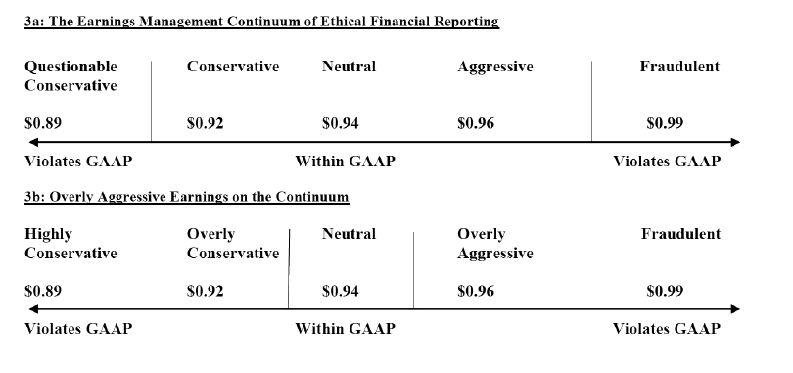

The Difficulty of Identifying Earnings Management
A commonly accepted evaluation of earnings management is that it is good at reducing lucidity by concealing the 'true' earnings of a company. Against this valuation, there are these leading academics who contend that both the level and patterns of earnings transport information and also even if Earnings Management obscures particulars, it can be favorable for the shareholders. In such an environment, the managed earnings stream can convey more information than the unmanaged earnings stream. Quantity of the earnings is the main focus of aggressive and deceptive accounting. They place less significance comparing with the quality earnings.

Research of the financial press has found that the company's success lies in earnings per share. To add more, the earnings per share is the most customary measure of executive performance in executive compensation. Bergstresser and Philippon have proven that discretionary accruals to control reported earnings are more distinct at firms where the CEO's potential total compensation is knit to the value of stock and option holdings.
Similarly, the discontinuity to zero in the frequency distribution of the change in net income deflated by market capitalization at the beginning of the period is not evident in the earnings per share. This is not surprising given the strong correlation between earnings per share and changes in earnings per share. In a subsequent investigation, Durtschi and Easton provided three sets of evidence that these discontinuities are likely to be caused by factors other than Earnings Management. They offered the following:
• A detailed analysis of the effects of sample selection in a recent study; this study erroneously concludes that the form of profit distribution is evidence of Earnings Management
• A simple explanation of the way of profit distribution is most often noted as evidence of Earnings Management; the ratio of earnings to prices differs based on the size and sign of earnings
• Other examples that support the main point of your article; Evidence beyond the form of distribution must be provided before researchers can conclude the presence or absence of revenue management.
Regulators consider earnings management harmful and require immediate remedial action. The SEC is always against any earnings manipulation. As Teko & Skinner (2000) speculate, financial statements and related disclosures remain intact, even if they include sufficient detail to allow investors to adjust to earnings management. The SEC's explanation for this is its mandate to ensure that the stock market is fair to buyers. However, it is the SEC's job to serve the best interests of every legitimate and rational market participant. Earnings management is beyond criticism because it is within formal constraints; therefore, it should not be identified as the target of regulatory enforcement actions. Because people are opportunistic, Achilles cannot blame others for taking advantage of heels.
For the same reason, if managers exploit the inadequacy of accounting standards and their ability to manage reported returns, it does not provide any reason for criticism. It is inappropriate to say that the use of deficiencies undermines the purpose of the standards. It is the rule-makers who are accountable. The quality of financial statements is an indirect indicator of the quality of accounting standards. If deviations from the rules cannot be eliminated, you must learn to live with revenue management. Being within legal limits, Earnings Management is beyond criticism; therefore, it should not be identified as a target for regulatory compliance actions.
Also, standard setters must keep pace with rapid changes in business practices to avoid recognition of accounting being delayed by economic events and to minimize the possibility of creative accounting practices. However, some companies openly ignore GAAP in the earnings report and ask the SEC to intervene. For example, in support of an initial public offering of $ 20 billion, the startup Groupon has highlighted in its regulatory documents a concept of result that we had not seen before in the Accounting literature: "Adjusted consolidated operating profit for the sector" (CSOI). According to this concept, the company has eliminated marketing costs, acquisition costs, stock compensation, interest expense, and tax payments (Cyran et al., 2011). Groupon said it had generated a profit of $ 81.6 million in the first quarter of 2011 when if only marketing expenses were deducted, the company had a loss of $ 98 million. Following SEC questions about its unusual concept of profits, Groupon said in an amended SEC statement that CSOI "should not be considered a discretionary measure of cash available to us to invest in the growth of our business or measure evaluation" (Raice and Wingfield, 2011).
In its 2001 annual report, the management of Enron stated, "We are focused on earnings per share" (Enron Corporation, 2002). Enron's cash flow performance was less than 1.0 thirteen quarters before its bankruptcy in October 2001. The measure was negative almost two years before its bankruptcy. During the last quarter, Enron (AccountingMalpractice) hid nearly $ 25 billion in liabilities (in billions)
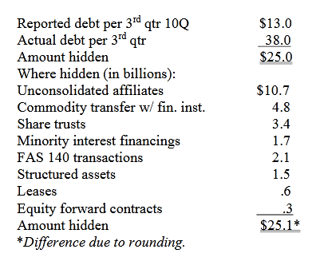
Selected Earnings Management Case Examples
1. The Microsoft Case
Microsoft did not recognize the product as a result of the U.S. Attorney General's antitrust investigation. This is perhaps an example of very conservative unacceptable Earnings Management, depicting that not all Earnings Management practices involve exaggeration. The Securities and Exchange Commission (SEC) considers Microsoft's accounting practices to be significantly misdiagnosed from July 1994 to June 1998. Microsoft failed to report its financial results accurately, resulting in higher revenues in some quarters and deficiencies in other quarters. The SEC said that Microsoft improved its financial results by artificially allocating large reserves to reduce revenue, changing that practice to record earnings in less profitable times. The total balance in the period under question was $ 200 million to $ 900 million. The SEC criticized the use of 'cookie-jar' reserves, which gives the investors an inaccurate picture of the company's current financial performance.
2. The Time Warner Case
Based on management's analysis of sales and returns and bad debt allocations, Time Warner established reserves of $ 2,253 billion and $ 2,229 billion as of December 31, 2009, and 2008. These estimates represent around 30% of gross receivables in the two years. Management explains that this is an "area of judgment that affects reported income and net profit" and is based on an analysis of "sales of products by the seller, historical performance trends, the current economic conditions and changes in customer demand "(Times Warner Inc., 2010). This may be an example of conservative to neutral Earnings Management.
3. The Southwest Airlines Case
After the September 11 crisis, Southwest Airlines changed the estimated lifespan of its aircraft from 22 to 27 years because improved maintenance methods allowed the company to get more useful years out of the plane. This change in accounting estimate, which does not require consistent disclosure in the auditor's report, allowed Southwest to continue to show year-over-year profit growth. The change in estimate and its result were disclosed in a note to the financial statements. This may be an example of acceptable neutral to aggressive (not overly aggressive) Earnings Management (Southwest Airlines Inc., 2003).
4. AT&T Inc. and Verizon Communications Cases
AT&T Inc. and Verizon Communications Inc. moved to account for retirement plans in 2010 by moving the market to the market. When the market collapsed since the financial crisis of 2008-2009, these companies suffered huge losses: AT&T to $ 23 billion and Verizon to $ 12 billion. Instead of recognizing these losses in their income statements for 2008-2009, the current U.S. government has not. The companies selected according to the standards to forgive them in future years (Rapoport 2011). In the 2010 financial statements, these companies choose to change the calculation of pension funds from the market to international standards and review the financial statements of previous years. An AT&T spokesperson said this improves accounting clarity so that "everyone can understand where the gains and losses recognized in our income statement at the end of each year are linked to actual economic events." And a spokesperson for Verizon said that the new approach "is, in fact, a preferable accounting method and that it aligns with fair value accounting concepts and the current [IASB] proposal" (Burr, 2011). This may be an example of aggressive Earnings Management.
5. The Dell Case
The Securities and Exchange Commission alleges that Dell misled investors by using money from chipmaker Intel. According to the SEC, company executives relied on Intel to make payments to meet or exceed Wall Street's expectations. "Dell was only able to consistently meet Wall Street goals during this period by breaking the rules." Without Intel's payments, Dell would have lost the consensus earnings-per-share estimate released by Wall Street analysts who tracked the company in each quarter of its fiscal years from 2002 to 2006. Exclusive payments have made up an increasing share. What Dell reported as operating profit from 10 percent in fiscal 2003 to 38 percent in fiscal 2006 and then climbed to 76 percent in the first quarter of fiscal 2007, said the SEC. In the settlement, Dell, several former executives and its founder, Michael S. Dell, agreed to pay more than $ 100 million in fines to settle the accounting fraud disclosure fees filed by the Securities and Exchange Commission (Wyatt, 2010).

CONCLUSION
In this paper, we discuss the Earnings Management continuum of ethical financial reporting, highlighting the difficulty of identifying cases of Earnings Management and providing global incidents in the past decade. From the extensive literature on revenue management and experience over the past decade, reform is needed to define the limits of acceptable accounting flexibility and the balance between principles-based standards and standards-based in the rules it needs to be better understood. The need to better understand the judgment is reinforced by the efforts of the Financial Accounting Standards Board (FASB) and the International Accounting Standards Board (IASB) to approximate US GAAP and International Financial Reporting Standards (IFRS). Through principles plus standards, the absence of decisive guidelines for principled standards can create inconsistencies in applying standards in companies and countries. On the other hand, rules-based standards are insufficiently flexible to react to a problem such as fair value, which often requires considerable judgment from experience, with limited market data.

REFERENCES
Arya, A., Glover, J., & Sunder, S. (2003). Are unmanaged earnings always better for shareholders? Accounting Horizons, Supplement 2003, 111–112.
Barth, M. E. (2018). The future of financial reporting: Insights from research.Abacus, 54(1), 66-78
Beasley, M. S., Carcello, J. V., Hermanson, D. R., & Neal, T. L. (2010). Fraudulent financial reporting 1998–2007: An analysis of U.S. public companies. Committee of Sponsoring Organizations of the Treadway Commission (COSO).
Bergstresser, D. & Philippon, D. (2006). CEO Incentives and Earnings Management. Journal of Financial Economics 80, 511–529.
Burr, B. (2011). Mark-to-market accounting helps companies shift pension plan losses. Pensions and Investments, February 21, 2011.
Christensen, T., Paik, D., & Williams, C. (2010). Market efficiency and investor reactions to SEC fraud investigations. Journal of Forensic & Investigative Accounting, Special Issue, 2(3).
Cyran, R., Currie, A., & Cox, R. (2011). Fuzzy accounting enriches Groupon. NYTimes.com,June 12. Available at: http://www.nytimes.com/2011/06/13/business/13views.htmlDechow,
Dechow, P. M. & Skinner, D. J. (2000). Earnings management: Reconciling the views of accounting academics, practitioners, and regulators. Accounting Horizons,14(2), 239.\
Durtschi, C. & Easton, P. (2005).Earnings management? The shapes of the frequency distributions of earnings metrics are not evidence ipso facto. Journal of Accounting Research, 43(4), 57–59.
Durtschi, C. & Easton, P..(2009). Earnings management? Erroneous inferences based on earnings frequency distributions. Journal of Accounting Research, 47(5), 1249–1281
Enron Corporation. (2002). 2001 Annual Report. Houston, TX
Feng, M., Ge, W., Luo, S., & Shevlin, T. (2011). Therole of CFOs in material accounting manipulations―the Executive Summary. The Conference Board, May 2011.
Healy, P. M. & Wahlen, J. M. (1999). A review of the earnings management literature and its implications for standard setting. Accounting Horizons,13(4), 365–383.
International Accounting Standards Board (IASB) (2010), The Conceptual Framework for Financial Reporting 2010, London: IASB.
Jackson, S. B. & Pitman, M. K. (2001). Auditors and earnings management. The CPA Journal, July 2001. Available at: http://www.nysscpa.org/cpajournal/2001/0700/features/f073801.htm.
Kripalani, M. (2009). India’s Madoff? Satyam scandal rocks outsourcing industry. [Electronic version]. Business Week,. January 2009. Available at: http://www.businessweek.com/globalbiz/content/jan2009/gb2009017_807784.htm.

